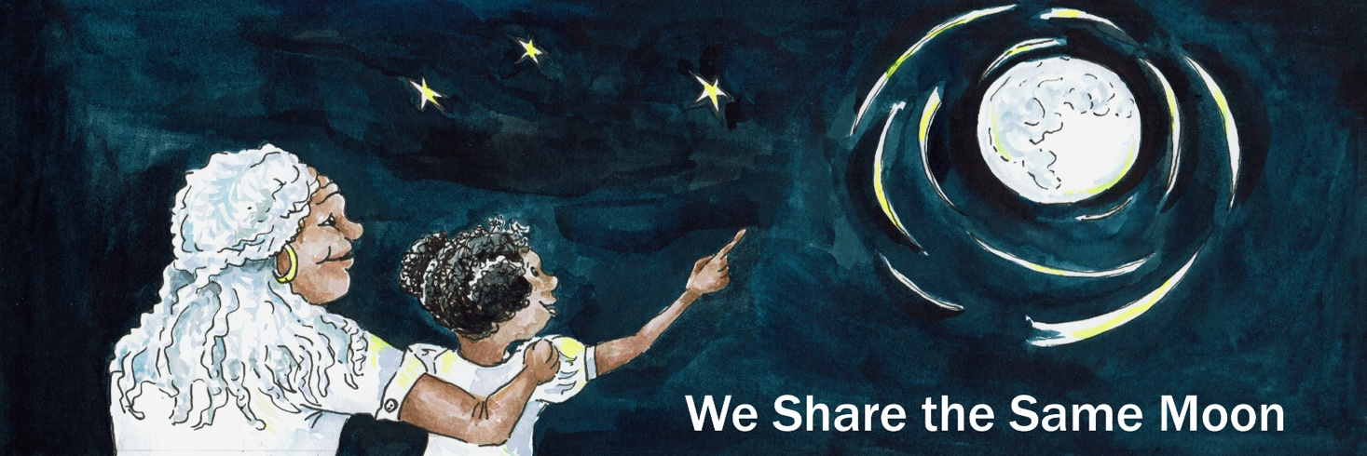

Suggested Age Range: 10 - 11 years; 11-12 years; 13 - 14 years; Adults
Suggested UK Year Group: Year 6
UK Curriculum: KS2; KS3
UK Primary Curriculum Link: Light
Science Subject: Eclipse
Science Question: Why do we have eclipses?
Suggested Science Activity: Eclipses
Children with SEND: Use to boost comprehension of science vocabulary in KS3
EAL children: For confident older learners
Country of Origin: England
Source:These Old Stories by Kevin Crossley Holland. Published by Colt Books UK

In the far far East of England, there lies a very special land, the marsh-land, a strange place that is somewhere between land and sea. And those who go into the marsh-land will only go when there is light. For without any light - it is very difficult to see the difference between a safe path and unsafe bog - is very small indeed.
It is so very easy, to take just one step, away from the path on solid ground, and into a quick, quick death, sinking beneath the marshy sand.
And what is more, it is said, that on the nights of the Dark Moon, when no Moon shines at all, the marsh-land is filled with evil spirits, will o’ the wisps and worse. Who are waiting to lure people away from that safe path and to their death in the quick, quick sand. Nobody, nobody at all would ever dare to go into the marsh without any light.
But, luckily for the dwellers of the marsh-land, both the town folk who follow one path and the gypsy folk who follow another, the Moon always shines the brightest over the marsh-lands of East England, because she loves the people who live there, she loves them all so very much.

Because …

Long ago one night the Moon, as she was rising in the sky, she looked down and saw a gypsy man, following the gypsy path through the Marshland. He had never been on his own before. He took one fearful step, just one step. His foot slid, and he found himself, falling, sinking down, down. He struggled to get out, but of course his struggles made him sink even faster.

Help, please, someone, anyone help me! He cried

But there was no-one to hear. Save for the Moon, so very far away in the sky. What could she do? The Moon, she pulled her coat of mid-night around her, and covered her silver shining hair, beneath its hood. And then she threw a shaft of silver light down to Earth, and she followed it down, down. Until she stepped onto the marshland - and felt it shift beneath her feet. Just one step was all she took. But the marsh was waiting …
The will o’ the wisps and worse. They hated the Moon. For the light she sent kept the people safe from harm. This was their chance for revenge. And they grabbed her by the foot and pulled her down. Down off the path, down into the marshy land and down she sank into the mud. They whispered into her ears …

Bury her. Drown her. Smother her. Kill her.
Bury her. Drown her. Smother her. Kill her.

But, the Moon would not give up. She grabbed a branch and pulled with all her might! And her hood threw back and freed her hair, and the air above, was filled with its shimmering shining light. And the gypsy man, he saw this shaft of light and it showed him the way out. He threw himself out of the mud and onto safe land, and then he ran as fast as he could, out of the marsh. Towards the light, the firelight of his camp, his home. And his people standing there around the fire, they saw him, and exclaiming at his plight, wrapped him in warm blankets and placed a warm drink into his shaking hand. And, within the light and warmth of the fire, he forgot, he forgot the one who had saved him. And so the Moon, she was alone, alone with the creatures of the Marsh.
They whispered into her ears …

Bury her. Drown her. Smother her. Kill her.
Bury her. Drown her. Smother her. Kill her.

And the will o’ the wisps slithered against her skin, as they took hold of her arms and pulled her down. And the bogles shivered against her face, as they grabbed her hair and pulled her down. And then, the dead hands of the ghosts slid around her and grabbed a stone and placed it upon her and pressed her down, down into the mud. And slowly, surely the Moon disappeared and her light went … out.

And at first no-one noticed. But, as the days, weeks, months passed there was still no Moon in sight. The town-folk and the gypsy-folk, knew that to cross the marsh at night without any light meant death. But the townsfolk had to get to market and the gypsy folk had to get to their next camp. What could they do? The towns-folk, they held a meeting, to which of course, the gypsies were not invited. But, one of them came and he stood at the back and listened. And then he remembered.

Excuse me, I think I know what might have happened to the Moon.

Men turned to listen, and when they saw who it was, most of them turned back again. But, some of them, some of them they listened. He told them, of how he been trapped in the Marsh and a strange silver light had appeared which he had followed until safe at home. Could it have been the Moon, trying to save him, and been trapped in turn?

Hah! Most of the townsfolk said Its just another gypsy tale.

And they turned away. But some of them believed him, and chose to follow him back to his camp. He led them to the camp, where the head-woman sat waiting for them. And she listened to their story whilst watching them all. And as the story ended, she nodded:

It is true, the Moon has been captured by the spirits of the marshland, and she is trapped there, buried beneath a stone. And you must go and pull the stone from her, and set her free.

Us, but, but, but we cannot go into the Marsh, without any light. It isn’t safe.

Oh Yes you can! You she pointed at some of the gypsy men.go out at night, poaching, stealing to find food for us all. And you, she pointed at some of the townsfolk, who looked a little shamefaced You are game-keepers, yes I know you are, don’t try and hide! I know you go after our men, I know you are enemies, sworn to stop them by whatever means you can. But tonight is different. Tonight you must work as one.
For only you can walk into the marsh at the dead of night.
And you must all go, for it will need all of you, to lift that stone.
And, mind, you must be as silent as you can, so that the marsh spirits do not capture and bury you in turn.

And the gypsy-men poachers and the towns-folk gamekeepers, it was the first time that they had ever walked anywhere together. But tonight, this was different. Tonight they had to change. So they walked side by side into the Marsh. With no light at all to guide them, they walked barefoot so they could feel the path beneath the sole of their skin. And as they inched their way together, it was as if they moved, they breathed as one. If one was to hesitate or falter, the other would gently guide him back, safe on the path. It didn’t seem to matter who saved who.
Together they walked, together they moved, they breathed, together they moved as one, as men of the Marsh, trying to keep safe their home. And together, they found the stone.
And together they stooped, together they grabbed, together they heaved!
And there was a flash of light so bright, they had to close their eyes!
And, when they opened them again, the Moon was back in the sky!
And then the Moon, sent a silver shimmering shaft of light - to guide her people home.
And THAT is why the Moon shines brightest over the marshlands of the East of England. Because she loves both the towns-folk and the gypsy-folk who live there so very very much. Always has and always will! Or at least that was what I was told!

Copyright Cassandra Wye, 2017, on behalf of The Lunar Planetary Institute, USA
Created for The Vanishing Sun https://www.lpi.usra.edu/education/explore/eclipse/

